**EXERCISE 02: Context, Dimension, Measure, Quick, Table Calculations Filters**

**Purpose**: Improve filter performance for downstream filters

**Scenario**: Limit analysis to the corporate segment, then filter by high-value sales.

Perform the following steps to complete the exercise:

1. Load the **Orders** table from the **sample** **Superstore** dataset in your Tableau instance.
2. Create a bar chart with **Sub-Category** and **Sales**.

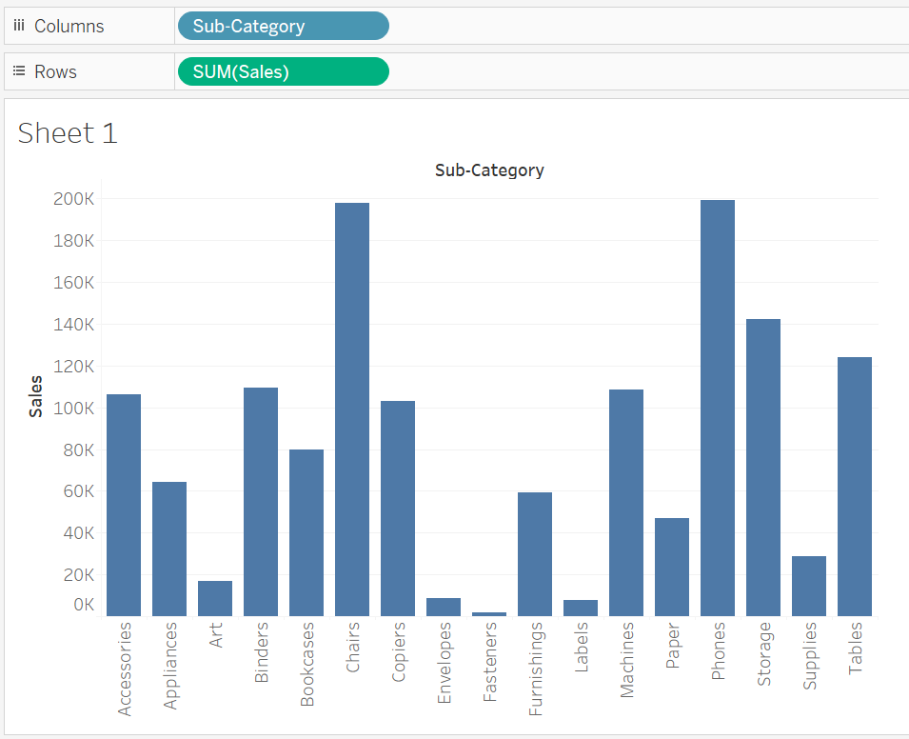

1. Drag Segment to filter shelf, and in the new window choose **Corporate** **(***explore other options).*Then click **ok**

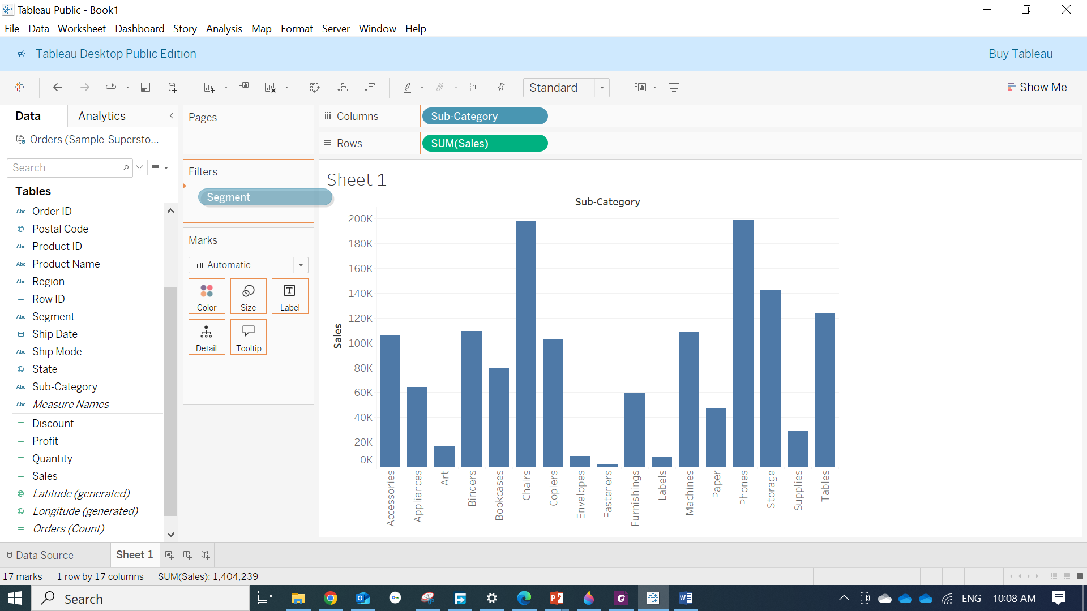 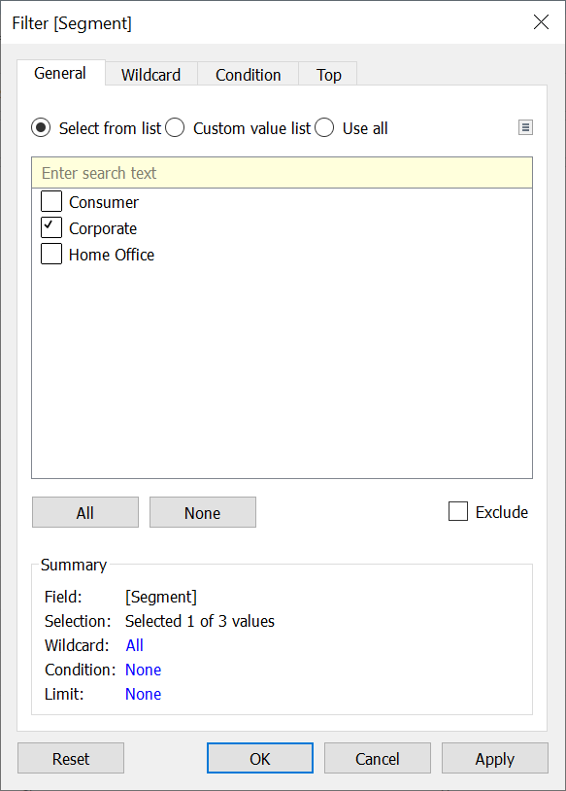

1. Right click on added filter and **Add to Context**.

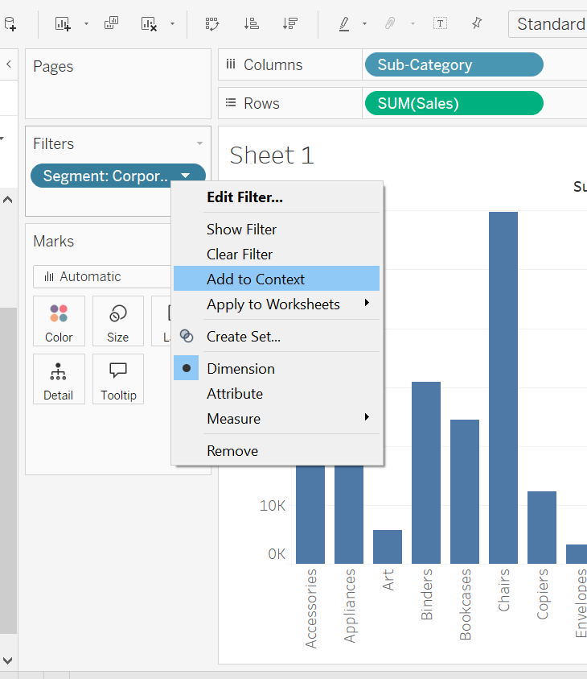

You will notice color of **Segment** filter will be changed to **Gray**

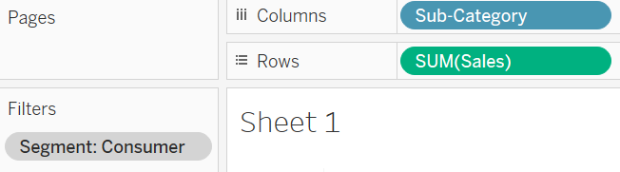

1. Add Sales filter following same steps before, and choose **# Sum,** and click **next.**

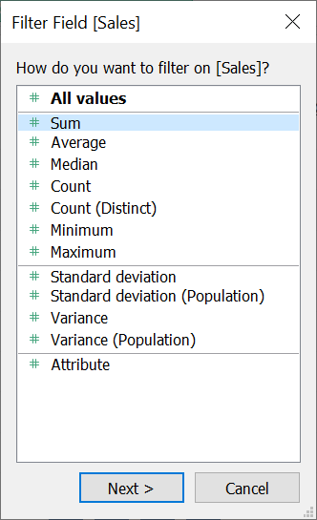

1. In the next window choose sales between 40,000 and 70,000 and click **Ok**.

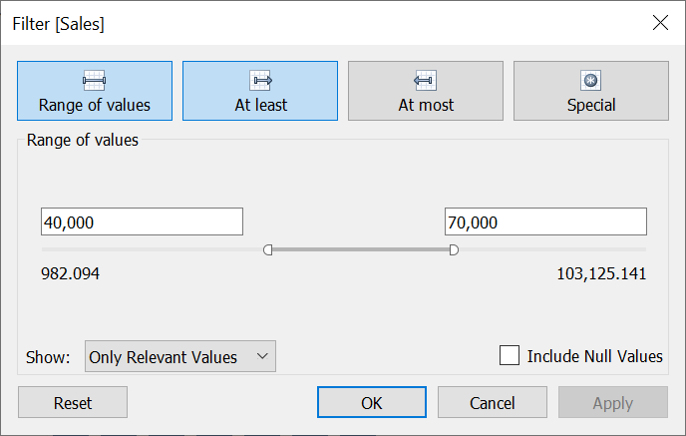

1. Add **Order Date** filter and choose **Range of Dates,** and click **Next.**

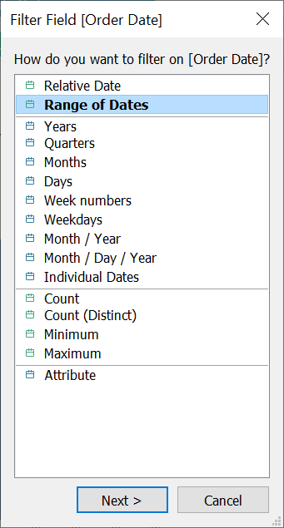

1. Select two dates as below, choose any two dates and see the effect on the chart.

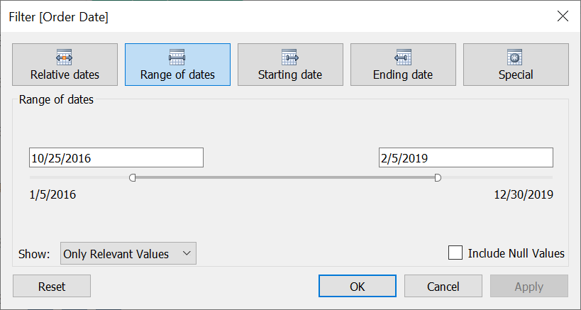

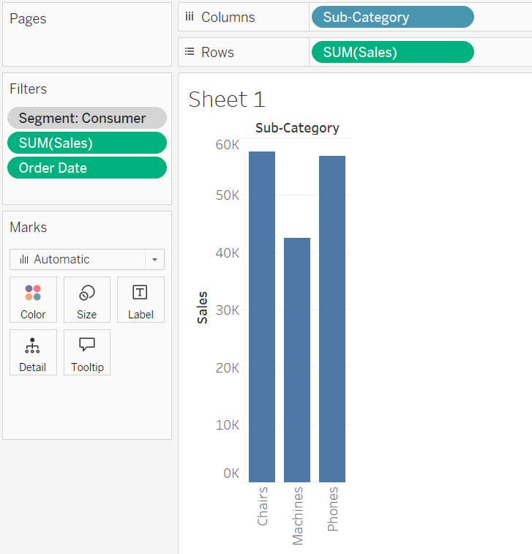

1. On **new Sheet** create a Bar Chart that shows **Sales** per **Category** and **Sub-Category**, as shown below.

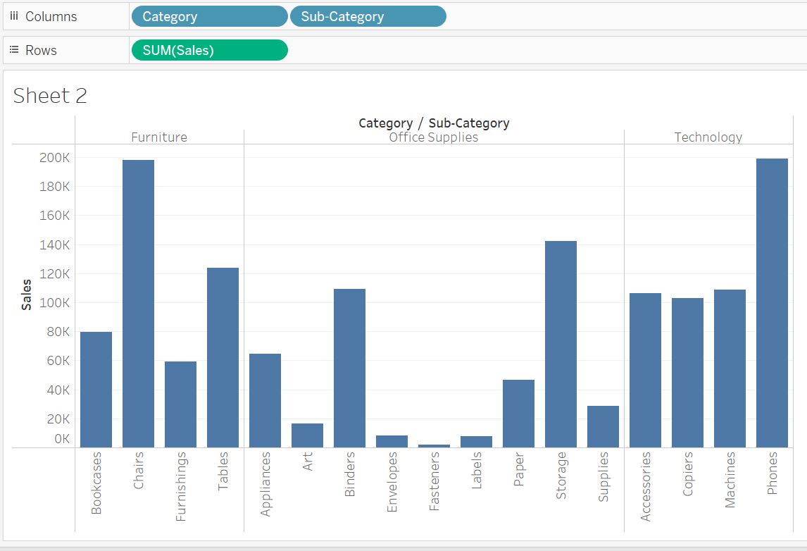

1. Go back to **Sheet 1** and right click on any filter, for example Sales Filter, and choose **Apply to Worksheets** then **Selected Worksheets.**

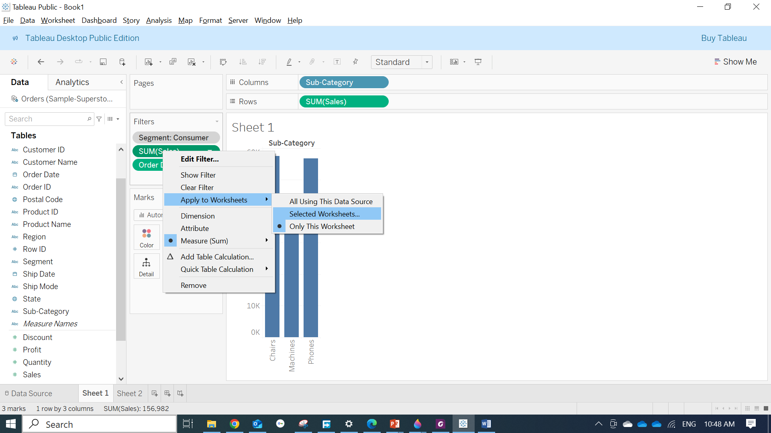

1. On the new window select the checkbox for **Sheet 2** as below, if you have more than two **Sheets** they will appear here and you can select all or any sheets among them. Then click **OK.**

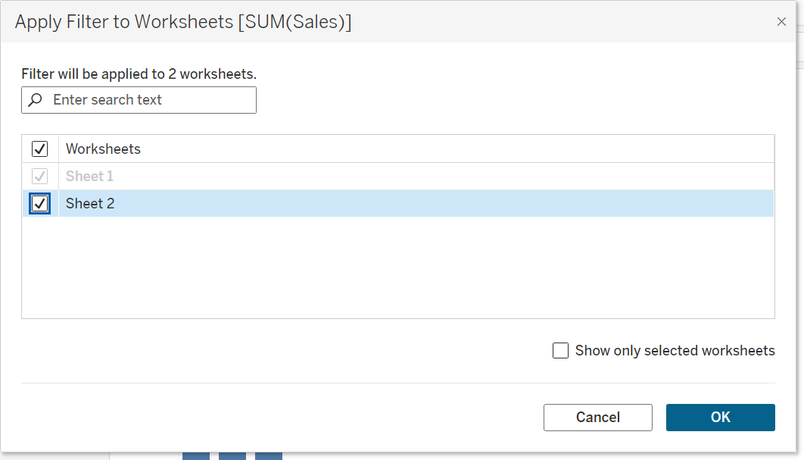

**Note: You can add calculated fields to the Filters shelf just like dimensions or measures**

1. Go to Sheet 2 and notice how filter applied

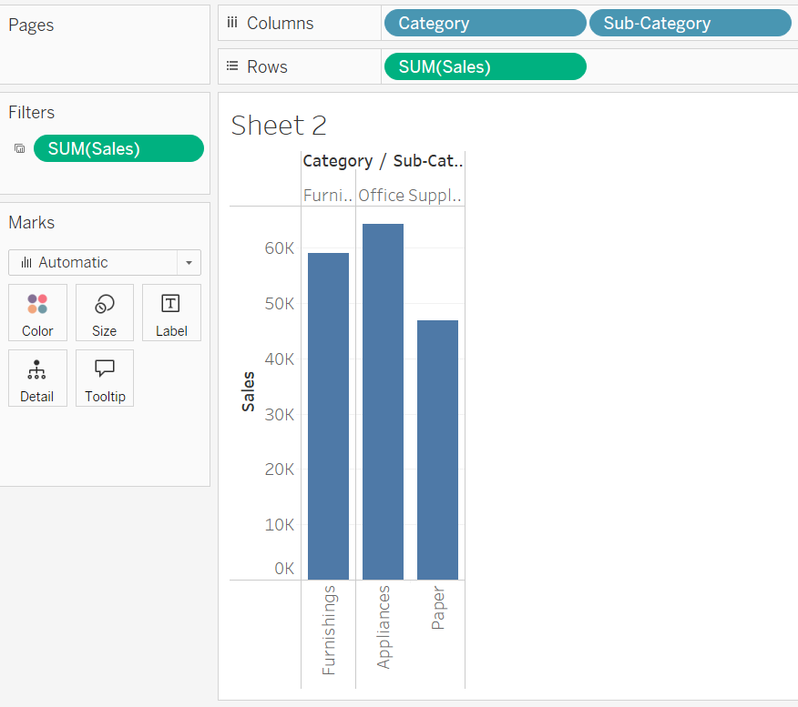

**Now in order to show filters (Quick Filters) for users so they can interact with it, follow the following steps:**

1. Right click on any filter that you want to appear to users and select **Show Filter**

**Note you can add quick filter without adding them to filter, by right click on any Measure or Dimension and click show filter. The difference that they will appear to end users.**

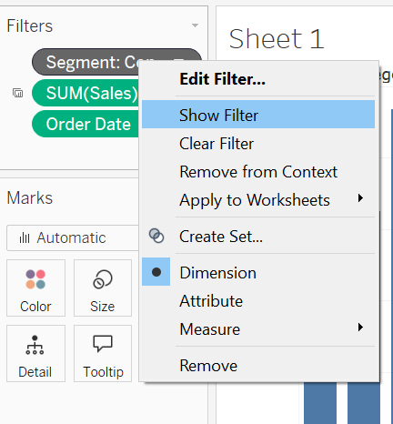

The filters will be displayed to the right pane of any sheet

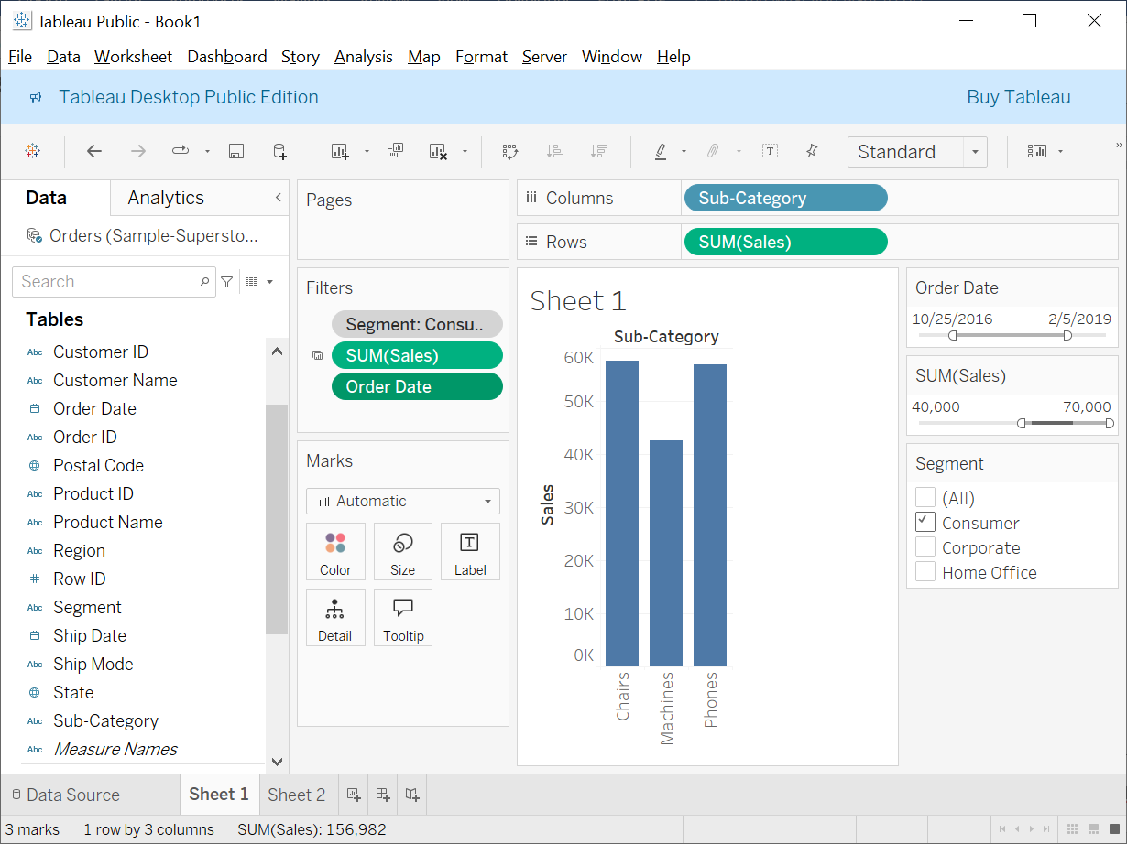

**Filter Card Menu (Formatting Quick filters):**

The **filter card menu** in Tableau, which appears when you **Right-click (or click the dropdown arrow) on the filter card** displayed on the right-hand side of the worksheet. It lets you **customize the behavior and appearance** of the filter control.

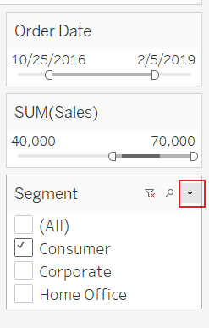 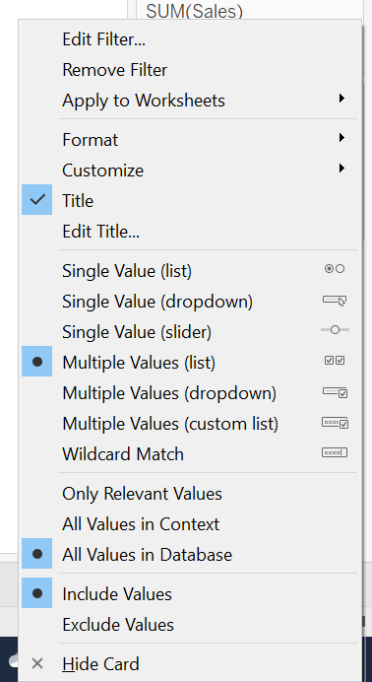

Here's a quick explanation of the key options:

**🔧 Main Actions**

* **Edit Filter...** – Opens the filter dialog to adjust filter logic.
* **Remove Filter** – Removes the filter from the worksheet.
* **Apply to Worksheets** – Lets you apply the filter to multiple sheets at once.
* **Format / Customize** – Controls the appearance of the filter.

**🏷️ Title**

* **Title** – Toggles display of the filter title.
* **Edit Title...** – Allows renaming the filter title.

**🔘 Filter Display Styles**

Choose how users will interact with the filter:

* **Single Value (list/dropdown/slider)** – Select only **one** value.
* **Multiple Values (list/dropdown/custom list)** – Select **multiple** values.
* **Wildcard Match** – Filter based on pattern (e.g., contains "Pro").

**⚙️ Value Options**

* **Only Relevant Values** – Shows only values relevant to other filters.
* **All Values in Context** – Shows values relevant to context filters.
* **All Values in Database** – Shows **all** values regardless of filter dependencies.

**🔄 Value Logic**

* **Include Values** – Normal filter behavior.
* **Exclude Values** – Inverse logic: hides selected values.

**🚫 Hide Card**

* Hides the filter card from the worksheet (does not remove the filter).